Recommendations for Prehospital Whole Blood Transfusion in Females of Childbearing Potential

Purpose: To provide guidance on the use of Low Titer Group O+ Whole Blood in the resuscitation of reproductive-aged females from trauma or medical causes, including pregnant patients, prior to admission to a treating facility.

LTOWB is indicated for the treatment of hemorrhagic shock from traumatic or medical causes and should not be delayed in reproductive-aged females, including pregnant patients

Definitions and Abbreviations:
- Reproductive age female: 12-55 years
- Low Titer O+ Whole Blood: LTO+WB
- Rhesus Factor: Rh
- Rh immunoglobulin: RhIG
Practice Guideline:

- For reproductive-aged females with clinical parameters indicative of hemorrhage shock from trauma or medical causes (e.g., ruptured ectopic pregnancy, pregnancy-related hemorrhage) who are unresponsive to initial resuscitative measures, administration of LTOWB prior to hospital arrival is indicated.

- Use of LTOWB is indicated for use in reproductive-aged females regardless of pregnancy status as the benefit of maternal life-saving measures outweighs potential risks to the pregnancy or future childbearing.
Special Considerations:
- Prehospital providers who are caring for pregnant individuals should maintain the same guidelines for initial evaluation and management as they would for a nonpregnant patient.

- In the pregnant patient beyond 20 weeks gestation (fundus at level of umbilicus), ensure displacement of uterus by placing maternal patient in left-lateral recumbent position to avoid hypotension caused by vena cava compression.

- Use of LTOWB may result in Rh mismatch where an Rh negative reproductive-aged female receives LTOWB.

- When clinically feasible, informed consent should be obtained from a reproductive-aged female prior to the administration of LTOWB. In emergent, life-threatening situations, when immediate transfusion is required and consent cannot reasonably be obtained, treatment should proceed under the principle of implied consent.

- Consultation of a women’s health provider is required for pregnant individuals who have a Rh mismatch later identified following resuscitation.

- All Rh-negative women should be counseled about risks to their future pregnancies and followed by a women’s health provider in cases of Rh alloimmunization.
Documentation requirements:
- When administering LTOWB to a reproductive-aged female, prehospital teams must notify the receiving facility of this life-saving treatment.

- When a Rh mismatch of a Rh negative reproductive-aged female is identified, a notification of the facility’s Transfusion Medicine Specialist/Pathologist or women’s health provider is required. Follow-up antibody testing at 4-14 weeks is required to be established at time of discharge with either treating facility or usual health provider. Additional management strategies that may be considered are provided in Best Practices.

- Rh-negative reproductive-aged females who receive Rh-positive emergency-release blood will undergo routine, hospital-based quality review to ensure RhIG evaluation and follow-up were completed

- If an EMS patient meeting the criteria of this document, receives blood product but subsequently refuses transport to a hospital, patient should receive the information below (Important Information Regarding Rh-Positive Blood Transfusion and Pregnancy) from the EMS agency

Best Practices for Reproductive-Aged Females:

- Example letter for reproductive-aged female patient following Rh mismatch during resuscitation:

[Date]
[Patient Name]
[Patient Address]

Subject: Important Information Regarding Rh-Positive Blood Transfusion and Pregnancy

Dear [Patient Name],

You recently received an emergency transfusion of whole blood or red blood cells (RBCs) to help save your life.

What is Rh(D)?

Rh(D) is a protein found on the surface of red blood cells. If your blood has this protein, you are considered Rh(D) positive. If your blood does not have the protein, you are Rh(D) negative. The "+" or "–" sign you might see after your blood type indicates whether you are Rh(D) positive or negative.

Why is this Important for Me to Know?

You have an Rh(D) negative blood type, but the blood you received was Rh(D) positive. This means there is a small chance your body could produce antibodies against Rh(D), called anti-D antibodies. This process is known as alloimmunization.

While these antibodies won’t affect your own health, they could pose a risk during future pregnancies. If you have anti-D antibodies, they could cause hemolytic disease of the fetus and newborn (HDFN), which may lead to low blood counts (anemia) in the baby during pregnancy. With early and proper prenatal care, HDFN can be managed and treated successfully.

What Should I Do Next?

You should have a blood test called a Type and Screen to check whether you have developed anti-D antibodies. If you have, your healthcare team will give you more information on what steps to take in the future, especially if you are planning a pregnancy. In the meantime, we recommend learning about what to expect in pregnancies affected by anti-D antibodies. You can find helpful resources and information at The Allo Hope Foundation website: www.allohopefoundation.org.

For any immediate questions, please contact your healthcare provider.
pregnancies.

Important Steps to Take: Complete antibody testing at least 4-14 weeks after exposure, either at [treating facility] or with your usual health care provider

- Example treatment algorithm for Rh mismatch in reproductive-aged female for use of RhIG. Specific treatment recommendations can be found in references.
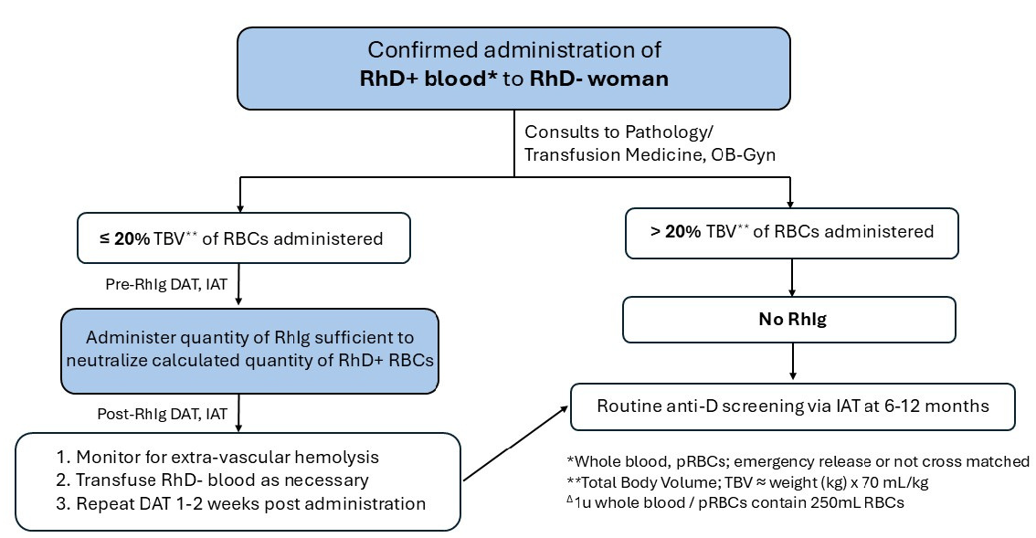

Note: some organizations may use differing threshold of total blood volume transfused in Rh mismatch, including observation only.

References:
- Critical Care and Trauma. In: Cunningham F, Leveno KJ, Dashe JS, Hoffman BL, Spong CY, Casey BM. eds. Williams Obstetrics, 26e. McGraw Hill; 2022.
- Critical care in pregnancy. ACOG Practice Bulletin No. 211. American College of Obstetricians and Gynecologists. Obstet Gynecol 2019;133:e303–19.
- Prevention of Rh D alloimmunization. Practice Bulletin No. 181. American College of Obstetricians and Gynecologists. Obstet Gynecol 2017;130:e57–70.
- Management of alloimmunization during pregnancy. ACOG Practice Bulletin No. 192. American College of Obstetricians and Gynecologists. Obstet Gynecol 2018;131:e82–90.
- Greco, Patricia S. MD; Day, Lori J. MD; Pearlman, Mark D. MD. Guidance for Evaluation and Management of Blunt Abdominal Trauma in Pregnancy. Obstetrics & Gynecology 134(6):p 1343-1357, December 2019
- Clements TW, Van Gent JM, Menon N, Roberts A, Sherwood M, Osborn L, Hartwell B, Refuerzo J, Bai Y, Cotton BA. Use of Low-Titer O-Positive Whole Blood in Female Trauma Patients: A Literature Review, Qualitative Multidisciplinary Analysis of Risk/Benefit, and Guidelines for Its Use as a Universal Product in Hemorrhagic Shock. J Am Coll Surg. 2024 Mar 1;238(3):347-357.
- Alkateb R, Mazzolini K, Prajapati VP, Harrison C, Ireland KE, Jenkins D, Daniels J, Greebon L. How I do it: An institutional protocol for the management of RhD negative women who receive RhD positive blood. Transfusion. 2025 May:65 Suppl 1:S320-S327.
- Levy ML, Schaefer RM, Obyrne H, Krohmer JR, Bank EA, Holcomb JB. Prehospital blood transfusion coalition clinical practice guideline for civilian emergency medical services. Trauma Surg Acute Care Open. 2025 Jul 16;10(3):e001931.

